Code style in MS TECH
Version 2 (Draft)



Naming conventions
Namespaces | Pascal Case, no underscores. Use Vestas.ProductName as root. | Vestas.GE.Bll  Vestas.Vpc2.UI.WinForm
Classes and Structs | Pascal Case, no underscores or leading “C” or “cls”.  Classes may begin with an “I” only if the letter following the I is not capitalized, otherwise it looks like an Interface.  Classes should not have the same name as the namespace in which they reside.  Never upper case abbreviations; e.g. use “XmlDocument”, not “XMLDocument”. | Widget  InstanceManager  XmlDocument
Collection Classes | Follow class naming conventions, but add Collection to the end of the name. | WidgetCollection
Delegate Classes | Follow class naming conventions, but add Delegate to the end of the name. | WidgetCallbackDelegate
Exception Classes | Follow class naming conventions, but add Exception to the end of the name. | InvalidTransactionException
Attribute Classes | Follow class naming conventions, but add Attribute to the end of the name. | WebServiceAttribute
Interfaces | Follow class naming conventions, but start the name with “I” and capitalize the letter following the “I”  Why: This convention is consistent with the .NET Framework and is easy to read. It also distinguishes classes from interfaces, where (unlike in VB6) are truly different beings. This avoid name collisions as well, as it is quite common to have Ifoo and a class named Foo that implements Ifoo. | IWidget
Enumerations | Follow class naming conventions. Do not add “Enum” to the end of the enumeration name. If the enumeration represents a set of bitwise flags, end the name with a plural.  Why: This convention is consistent with the .NET Framework and is easy to read. | SearchOptions (bitwise flags)  AcceptRejectRule (normal enum)
Functions and Subs | Pascal Case, no underscores except in the event handlers. Try to avoid abbreviations. Many programmers have a nasty habit of overly abbreviating everything. This should be discouraged.  Functions and subs must differ by more than case to be usable from case-insensitive languages like Visual Basic .NET  Why: This convention is consistent with the .NET Framework and is easy to read. | VB: Public Sub DoSomething(…)  C#: public void DoSomething(…)
Properties and Public Member Variables | Pascal Case, no underscores. Try to avoid abbreviations. Members must differ by more than case to be usable from case-insensitive languages like Visual Basic .NET.  Never upper case abbreviations; e.g. “SomeId” should not be “SomeID”.  Why: This convention is consistent with the .NET Framework and is easy to read. | VB: Public Property RecordId As Integer  C#: public int RecordId {get;set;}
Parameters | Camel Case. Try to avoid abbreviations. Parameters must differ by more than case to be usable from case-insensitive languages like Visual Basic .NET.  Never upper case abbreviations; e.g. “SomeId” should not be “SomeID”.  Why: This convention is consistent with the .NET Framework and is easy to read. | VB: ByRef someId As Integer  C#: int someId
Procedure-Level Variables | Follow parameters naming convention  Why: This convention is consistent with the .NET Framework and is easy to read. It also avoids naming collisions with class-level variables (see below) | VB: Dim someId As Integer  C#: int someId;
Class-Level Private and Protected Variables | Camel Case with Leading Underscore. In VB.NET, always indicate “Protected” or “Private”, do not use “Dim”. Use of “m_” is discouraged, as is use of a variable name that differs from the property by only case, especially with protected variables as that violates compliance, and will make your life a pain if you program in VB.NET, as you would have to name your members something different from the accessor/mutator properties.  Why: In a nutshell, this convention is simple (one character), easy to read (your eye is not distracted by other leading characters), and successfully avoids naming collisions with procedure-level variables and class-level properties. | VB: Private _recordId As Integer  C#: private int _recordId;
Form controls | Controls should be named for their function rather than their type.  Do not use type prefixes like “tb”, “lbl”, “chk” etc. Type prefixes make refactoring harder, and it’s the IDE’s task to know about types.  Controls should be named using the same rules as all other member variables – though omitting the leading underscore for private controls is allowed.  Suggestion (MIFTH): Postfixing control names is recommended and in some cases inevitable. E.g. If you are having a Label and a TextEdit containing e.g. a “Name” the names of the Label and TextEdit should be NameLbl and NameEdit.  Recommendd Postfixes are:  Labels: Lbl  Generel edit controls (incl. TextEdit, CheckBox and ComboBox): Edit  Buttons: Btn  Menu items: Mnu  Panels: Pnl  Forms: Form | address, not tbAddress  sendMail, not chkSendMail  AdressLbl or AdressEdit or SaveBtn or SaveMnu is recommended.
Constants | Same naming conventions as public/private member variables or procedure variables of the same scope. If exposed publicly from a class, use PascalCase. If private to a function/sub, use camelCase..  Do not use SCREAMING_CAPS  Why: This convention is consistent with the .NET Framework and is easy to read. A sizable section of the Framework Design Guidelines is dedicated to why they chose not to go the SCREAMING_CAPS route. Using SCREAMING_CAPS also exposes more of the implementation than is necessary. Why should a consumer need to know if you have an enum, or (perhaps because they are strings) a class exposing public constants? In the end, you often want to treat them the same way, and black-box the implementation. This convention satisfies that criteria. | SomeClass.SomePublicConstant  localConstant  _privateClassScopedConstant
Objects | Camel case.  Don’t suffix your objects with “object type hints”. This makes refactoring troublesome, and listing the object should be a task for the IDE anyway.  For example, use List<Customer> customers = new List<Customer>();  - and not List<Customer> customerList = new List<Customer>(); | List<Customer> customers = new List<Customer>();  var users = new Dictionary<int, User>();
Acronyms | Acronyms of three or more letters should always be pascal case (Xml instead of XML) instead of all caps.  Two letter acronyms should only be all caps if they indeed are an abbreviation of two words – “UI” is but “ID” is NOT! | Xml  Html  Id  UI
var | Use of the C# keyword “var” is strongly encouraged, as it makes refactoring code much easier. | var user = GetUser();

Formatting style
Braces layout | Place braces on the end of the line separated by a white space. | public int UserId {  get {  return 4;  }  private set {  _userId = value;  }  }
Force braces | Always wrap statements in brackets, even if they are one-liners. | if(condition) {  return true;  }  foreach(var user in Users) {  user.Invalidate();  }
Tabs | Use tabs instead of white spaces. Tabs should be 4 white spaces wide.
Blank lines | Maximum one blank line between two lines of code | private int _userId;  private string _name;  public User(int userId, string name) {  ...  }
New lines | Always place statements on new lines. | if(condition) {  ...  }  else {  ...  }

Solution structure

Solution folders
It is encouraged to use solution to group related projects – e.g. a “DataLayer” solution folder for the two projects generated by LLBLGen.

Namespaces versus project folders
Namespaces must follow the path in the project folders.
Consider the following (partial) project structure:
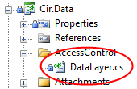
In this structure, the DataLayer class must reside in the namespace Cir.Data.AccessControl, because the root namespace is Cir.Data (the name of the project) and the class is placed in the sub folder AccessControl.
When moving files around, make sure to update their namespace accordingly.

Classes
Place all classes in separate code files. The file must have the same name as the class.
When renaming a class, make sure the code file is also renamed.
The use of nested classes is strongly discouraged.

Good coding practices
- Avoid hard coded strings and magic numbers in your code. If you really do need some, they should be encapsulated as constants in a proper location – e.g. an environment class or similar.
- Use a StringBuilder for concatenating strings. Appending strings to each other requires more overhead than you might think. Consider the following code:
The two methods return the same value, but Example1() actually allocates five new strings in memory and copies the existing string value to the newly allocated string with each append, while the StringBuilder in Example2() provides a much more efficient way of allocating new space when needed.
public class Example {
public string Example1() {
var theString = "SELECT u.UserId, u.UserName, g.GroupName ";
theString += "FROM User u ";
theString += "JOIN Group g ON g.GroupId = u.GroupId ";
theString += "WHERE u.Deleted = 0 ";
theString += "ORDER BY u.UserName ASC";
return theString;
}

public string Example2() {
var theString = new StringBuilder();
theString.Append("SELECT u.UserId, u.UserName, g.GroupName ");
theString.Append("FROM User u ");
theString.Append("JOIN Group g ON g.GroupId = u.GroupId ");
theString.Append("WHERE u.Deleted = 0 ");
theString.Append("ORDER BY u.UserName ASC");
return theString.ToString();
}
}
- Only expose the methods and properties on a class that need to be visible for others. You should always use the most restrictive access modifier possible from the following order:
  - Private
  - Internal protected
  - Protected
  - Internal
  - Public
- All fields (member variables) should be private and exposed (if necessary) through properties.
- Use read-only properties whenever possible; don’t implement the property setter unless it is really required.
- Write robust code. Think of your code as an API for third party developers. Everything that has been made accessible from outside your class should be able to handle being called by someone else’s code at random, without causing the system to fail or data to become corrupt.

Visual Studio settings
Everyone must use the same Visual Studio settings for code formatting. This ensures that Visual Studio auto formats code in the same way for everyone. Not doing so can potentially render the Source Control history useless for our source code.
The settings are available for download on the team site.
Visual Studio settings are imported from the menu Tools → Import and Export Settings… - as a minimum you must import the Text editor settings.
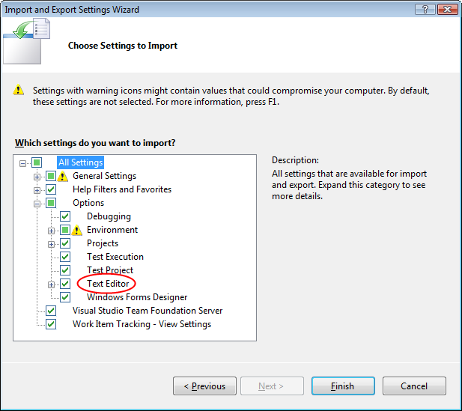

ReSharper settings
Everyone must use the same ReSharper settings for code formatting. With these settings, ReSharper will let you know when you are writing code that violates the code formatting rules.
The settings are available for download on the team site.
ReSharper settings are imported from the menu ReSharper → Options…
